BIOC404 Mar. 15th, 2006

The teacher started by reviewing part of what we had seen in the previous class:
The strategy for homonuclear assignment is in 2 steps;
- Identification of the spin systems using COSY and TOCSY.
- Ordering the spin systems using NOESY.
The procedure uses backbone amide resonances, because those signals are usually well spread out and separate from other signals, as well as cross-peaks between amide protons and H-αs (Hs on α-Cs). For small peptides, 2D spectrums are usually sufficient to resolve overlap between peaks.
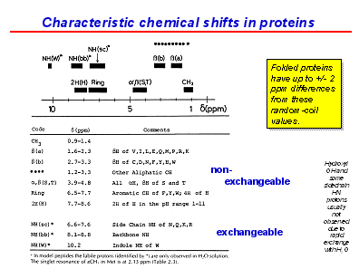
This slide shows that some protons exchange with the solvent (H₂O), Namely the amide protons (NH) of the backbones and side chains.
Note that hydroxyls exchange with the solvent so quickly that their resonance always overlaps with that of water and thus their signal cannot be distinguished.
Also, if measurements are taken in D₂O instead of H2O, the Hs on amides will exchange for Ds and the amide signal will be lost, and only the signals from Hs that are on carbons will be seen.

(This is slide 90 in final version)

The regions of the spectra that we should be able to recognize are:
- NH(W): Amide on Tryptophan’s Side chain at 10.2 ppm
- NH(sc): Amide on the side chain of other amino acids at 6.6-7.6 ppm (N, K, Q, R)
- NH(bb): Amide on the back bone of amino acids at 8.1-8.8 ppm
- α: H-α protons at 3.9-4.8 ppm
- Ring: Aromatic carbon hydrogens on F, Y, and W.
- CH₃: Methyls at about 1 ppm
- β(S,T): Hs on β-carbons of Serine and Threonine side chains at 3.9-4.8. These signals are moved downfield by the presence of an electronegative Oxygen
- β(b): Hs on β-carbons of shorter side chain amino acids at 1.6-2.3 ppm
- β(a): Hs on β-carbons of longer side chain amino acids at 2.7-3.3 ppm
For example: Aspartic acid has a shorter side chain than Glutamic acid (Glutamate has an extra CH₂), such that the β-proton is closer to the electronegative Oxygen, so it is located downfield relative to the β-proton of glutamic acid. The same principle applies for the other amino acids, so a shorter chain means the signal is more downfield.

Note that these values are applicable to small peptides and random coils; signals tend to spread out more in folded proteins (value ± 2).

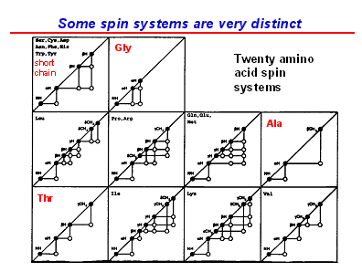
Some amino acids have a spin system that is easily identified by its cross peaks:
Alanine: It has a cross peak between a βCH₃ (Methyl) and an α-H and it has no β-H.
Glycine: It has no β-H and it has a NH with cross peaks with two α-Hs.
Threonine: It has a βCH₃ and does have a β-H.
Valine: It has two βCH₃ coupled to one β-H
So in short, some amino acids have very recognizable spin systems, and the teacher wished to highlight Alanine and Glycine. (This is slide 91)

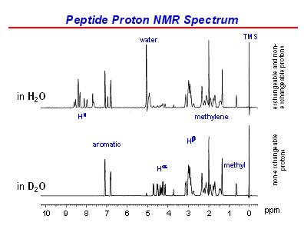
This slide compares two spectrums of the same peptide, one taken in H₂O and the other one taken in D₂O.
In D₂O, the HN signals are all lost (all exchangeable protons) and only the aromatic signals are seen in the downfield region.
The water signal is also lost, which allows you to see the H-α signals better.

Note that it is possible to “suppress” the water signal in the H₂O sample, but this causes the H-α signals to be weakened, so using D2O allows you to see H-α signals better.

(This is slide 93)
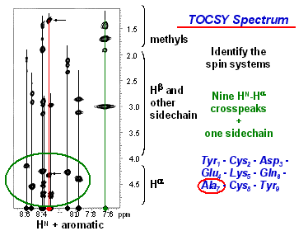
On this TOCSY spectrum, we identified one of the spin systems, the one with the red line going through it and that has arrows pointing to it.
This system has cross peaks between an HN (amide proton) at ~ 8.3 ppm, a signal at ~1.4, which corresponds to a Methyl H and a signal at ~ 4.5, which corresponds to an H-α. We saw earlier that this is the characteristic spin system of Alanine.
(Remember that TOCSY experiments show cross peaks between all Hs in the same spin systems, not just those on adjacent atoms)
(This is slide 98)

The teacher summarized the homonuclear assignment strategy by saying that it consists of first identifying the spin systems and then aligning them using NOEs. This method works well with peptides and small proteins. However as we get to larger, more structured proteins, some problems appear:
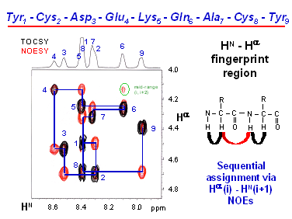
1- Instead of seeing only sequential NOEs, which allow us to order the spin systems in a peptide, we start seeing medium range NOEs (NOEs between non-adjacent residues).
In this TOCSY and NOESY spectrum, there is a circled peak near the top right. It is a cross peak NOE between residues that are separated by another residue (i, i+2).
So in larger peptides, you must worry about distinguishing between sequential and non-sequential NOEs.
2- Another problem with larger peptides is that we start seeing signal overlap. For example, the NOE between 4 and 5, could be seen as a cross peak between 4 and 8 instead or 4 and 1. (Slide 102)

Solution: Extended Homonuclear strategy, where ¹⁵N labeling is added. This helps solve the second problem by giving an extra label on amide peaks, allowing us to separate them. With this method, when we get overlapping amide signals, we measure an additional frequency (¹⁵N) which will spread our spectrum in 3 dimensions.
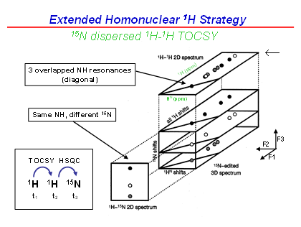
For example, here we have a 2D homonuclear spectrum (the plane with a short arrow pointing to it) on which we have three NH resonances overlapping on the diagonal, because they have the same NH chemical shift (These would be amides 1, 5 and 8, from slide 102).
By measuring the ¹⁵N frequency, we can separate the 2D spectrum into 3 sub-spectra in a third dimension, because the 3 amides have different ¹⁵N chemical shifts.
Now that the amides and their spin systems are no longer overlapping, we can identify the amino acid to which each corresponds.
The axes on the 3D spectrum are:
F1: Proton
F2: Proton
(This is slide 109) F3: ¹⁵N
Adding ¹⁵N to get an additional dimension can be applied to both TOCSY and NOESY experiments.

So again, to summarize the homonuclear assignment strategy:
- Proteins of size up to ~10kDa can be identified with 2D, without ¹⁵N labelling.
- Proteins of size up to ~20kDa can be identified with 3D, by adding ¹⁵N labelling.
- First, we use scalar coupling experiments (COSY and TOCSY), which shows couplings that go through bonds to get resonances that are within individual spin systems. Then we identify the amino acid corresponding to each spin system using characteristic cross peaks.
- Second, we use dipolar coupling experiments (NOESY), which shows couplings that go through space, allowing to get cross peaks between one residue (i) and the next(i+1) (These are called sequential NOEs, there are also mid-range NOEs, from i to i+2, i+3or i+4 and long range NOEs, i to i+5 or more).

Heteronuclear assignment strategy

This is the strategy used for larger proteins. It first requires us to use uniformly ¹⁵N/¹³C labelled proteins, where every C and N is isotopically labelled. This can be done by:
- Growing bacteria in minimal media where the sole source of carbon is ¹³C-glucose (100-200$/g) and the sole source of nitrogen is ¹⁵NH₄Cl (25-20$/g).
- Other systems can be used (e.g. yeast), however they are much more expensive.
Note that protein yields in minimal media are lower than in enriched (un-labelled) media, so for that reason as well as because of the cost of the media, it is important to have systems were we have very good expression of the recombinant protein.
This method allows us to make backbone assignment for proteins up to ~70kDa in size and full structure determination for proteins up to ~40kDa in size.
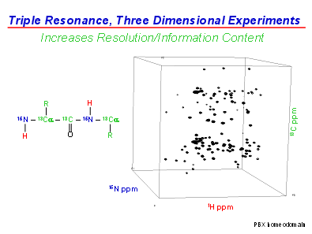
Labelling carbon and nitrogen allows us to acquire 3D spectra that are truly heteronuclear in that each axis is a different nucleus, meaning that we don’t get any more diagonal peaks (which do not give information).
In this spectrum, we have the amide hydrogen atoms on the horizontal axis (usually 6-10ppm), the α and side chain carbon atoms on the vertical axis (10-70ppm) (we don’t see the carbonyl carbon because it is extremely downfield) and the amide (and possibly side chain) nitrogen atoms are found between on the “depth” axis (90 -120 ppm).
This 3D spectrum removes overlap, however it is impossible to tell which peaks line up. The solution is to take projections of this cube.
(This is slide 114)
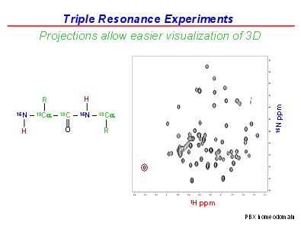
For example, this is a projection of the 3D spectrum showing the H and ¹⁵N axes in 2D (So we are looking into the cube from the top).
We can read the H and ¹⁵N chemical shifts of a given amide, for example the one that is circled in red because it is the only one at that H chemical shift.

Then we can look at the H and ¹³C projection (looking into the cube from the front) and look for the same amide hydrogen atom shift.

(This is slide 115)

This is the H and ¹³C projection. If we look at the same H chemical shift as in the previous projection, we can see the α-carbon and β-carbon chemical shifts of that same amide.

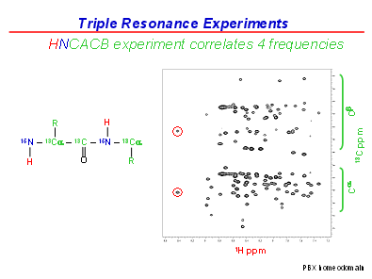
Question from the class: Where are the carbonyl ¹³C chemical shifts on the spectrum? They do appear in this experiment but we will not discuss them in class. We don’t see them on this spectrum because they are located way downfield at ~200 ppm, because of the electronegative O. (This is slide 116)

The overall strategy for heteronuclear assignment is similar to homonuclear assignment in that we identify spin systems of amino acids and then place them in order. One difference is that we have many more “flags”: we have amide Hs, α-C Hs, β-C Hs, ¹³C and ¹⁵N. This helps us avoid overlap between peaks in larger proteins.
The second, more important, difference is that we will not use NOEs to order the residues: we will instead use scalar (J-) couplings. The advantage over NOEs being that we cannot get mid and long range scalar couplings, only couplings between a residue and the one in front or behind it.
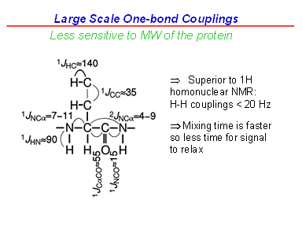
So we first identify spin systems by measuring HN (amide), ¹⁵N and C-α and C-β chemical shifts and then order them using scalar couplings.

We are going to look at 1-bond scalar couplings, which are large because they go through only 1 bond, and large couplings are easier to deal with for large proteins.
An example of these experiments is to first measure the amide hydrogen chemical shift (H on the nitrogen), then move the magnetisation to the ¹⁵N, then move to the α-¹³C and then to the β-¹³C. So we measure 4 frequencies for each amino acid: proton, ¹⁵N, α-C and β-C. (This is slide 119)
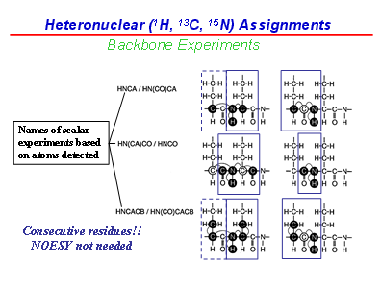
There are different experiments of this type, and they are named by the sequence of the atoms that are measured. We only discussed two of them: HNCACB, which is the one we just saw, where magnetization moves from the H to the N, to the α-C to the β-C and HN(CO)CACB, where we move from H to N, skip over the Carbonyl(CO), then move to α-C and then β-C.

We will use these two experiments to determine the ordering of the spin systems in the following way: The scalar coupling (cross peak) between the N and the α-C in an HNCACB experiment is only slightly larger than the scalar coupling between the N and the α-C of the preceding amino acid in an HN(CO)CACB experiment
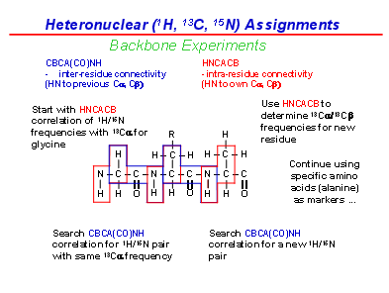
So when we find two amides, one from an HNCACB and one from an HN(CO)CACB, that have equal scalar couplings between a N and an α-C, we know that the two corresponding residues are linked together.
Here is an explanation of how we would order the residues:
- We measure HNCACBs and HN(CO)CACBs and get a 3D spectrum with amide H frequencies in one axis, and ¹³C and ¹⁵N in the other axes.
- Then we take a slice of the spectrum at a given ¹⁵N frequency, so that we get a 2D spectrum with only the peaks that are at the specified ¹⁵N frequency (This is different from a projection).
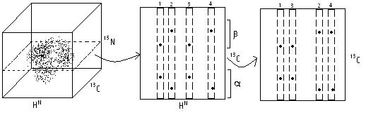
- In this example, we have 4 different ¹⁵N resonances that have the same ¹⁵N frequency but 4 different amide H frequencies. So we have 4 residues.
- Now we take 4 strips from the 2D spectrum, and we can see that the peaks on the ¹³C axis line up between strips. We move the strips where the α-C and β-C peaks line up next to each other. In this case, residues 1 and 3 are next to each other and 2 and 4 are next to each other.
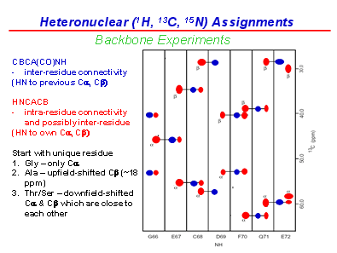
Once we have done this for several slices of the cube at different ¹⁵N frequencies, we obtain a “Strip plot”, such as the following:
The strips have been moved to next to other strips that have the same α-C and β-C peaks. Also, we can tell which of a pair of residue is after the other because, in the HN(CO)CACB exp. the magnetization moves over the carbonyl towards the previous residue.
So the peaks from the HN(CO)CACB exp. (in blue in the figure), are from the second residue of a given pair.

We can determine the amino acid to which each spin system corresponds, according to their peculiarities (Much like in homonuclear assignment):
- Glycine: Only has an α-C (no β-C) and its α-C chemical shift is unusually up-field (around 45ppm specifically- this will help if there is a glycine in the final)
- Alanine: Their β-C are CH₃, CH₃ Hs and Cs have distinct shifts (Out of scale in the figure) – i.e. below 20ppm! Usually between 10-20 ppm.
-Serine and Threonine: Because they have Oxygen on their β-Cs, their β-¹³C shifts mix with α-C shifts downfield. (Sometimes, the beta carbon of a serine or threonine is even more downfield than the alpha carbon! In fact this is often the case. 60-70ppm)

Here is a figure that might help- it was taken from http://www.nmr.chem.uu.nl/~aurelien/
